SOILS IN INDIA

Soil is the uppermost layer of Earth’s crust.
Soil is the medium in which plants grow and thus it supports the lives on earth.
How soils are formed?
Soils are formed due to the weathering of rocks.
WHAT IS SOIL?
Soil is the thin layer of loose mixture of small rock particles and rotting organic matter that covers much of the world’s land surface.
SOIL FORMATION
Soil formation is a very long process. It begins with the weathering of rocks into small fragments. The rocks are also worn away by the agents of erosion like river, wind, sea and glacier. The sediments and tiny rock particles are then deposited by the agents of erosion. The accumulation of such sediments over the ages forms soil. Eventually, the plants that grow on the soil, shed their leaves which decay to form the topmost layer of soil called 'humus'.
India is primarily an agricultural country. The success of agriculture depends upon the fertility of soils. The soils of India are classified into the following main groups depending upon the rock cover and climatic conditions.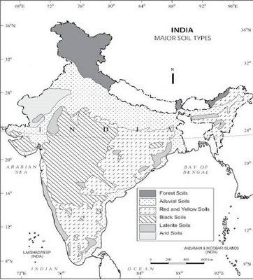The most two important factors that determine the types of soil found in India are : i. The climate ii. The topography
The soils of India on the basis of their formation are divided in the following two broad catagories.
1.Residual Soil
2.Transported Soil
The major soil groups are:
Black Soil
Black soils are mainly found over the Deccan lava tract (Deccan Trap) including Maharashtra, Madhya Pradesh, Gujarat and Andhra Pradesh. These soils are found in river valley of Narmada, Tapi, Godavari and Krishna. These soils have been formed due to the weathering of the lava rocks. This is also known as the Regur soil and Cotton soil. These soils are rich in lime. iron, magnesia and alumina butlack in the phosphorus, nitrogen and organic matter.
It is formed by the weathering of igneous rocks and the cooling of lava after a volcanic eruption.
In India, extensive deposits of black soil are found in the Deccan Plateau which includes parts of Maharashtra, Madhya Pradesh, Gujrarath, Andhra Pradesh, parts of Tamil Nadu.
In the upper parts of Godavari and Krishna, the north western part of Deccan Plateau, black soil is very deep.
BLACK SOIL IS:-
- Clayey, deep and impermeable
- They swell and become sticky when wet and shrink when dried
- During dry season, these soils develop wide cracks.
- Rich in lime and iron, magnesia and alumina
- Also contain potash
- Lack phosporus, nitrogen and organic matter
- Colour of the soil ranges from deep black of grey.
- Known as Black Cotton Soils.
- Dark in colour, suitable for cotton cultivation Are residual soils, i.e. they are formed at the place of their origin over the underlying rocks.
- Are formed in situ, i.e. formed where they are found.
Therefore, they are essentially formed by weathering of Deccan Trap.
- Spread over an area of 5.4 sq. km., i.e. 16.6 % of the total land area of the country.
CHARACTERISTICS:
* Fine textured and clayey in nature .
* Has high qualities of lime, iron, mangnesium, and generally poor percentage of phosphorous, nitrogen and organic matter.
* Black in colour as it is formed from weathered lava rocks
- Soil’s colour also varies from Black to Chestnut brown
- Very clayey and therefore highly retentive of water. Because of high clay content, these soils expand when wet and become difficult to plough.
- During dry season, black soils shrink and develop big cracks which help in air circulation .
- Soil is very fertile in most of places.
- Poor in nitrogen, phosphorous, potassium, and organic matter and rich in potash and lime.
- Needs irrigation support for cultivation
- Contains soluble salts in small quantities.
- Cultivation is done with the help of fertilizers .
- Suited for dry farming as it does not require much moisture.
CROPS:
- Cotton cultivation
- Suitable for growing cereals, rice, wheat, jowar, oilseeds, citrus fruits and vegetables, tobacco and sugarcane.
- Their moisture –retentiveness makes them suitable for dry farming.

Shall we revise black soils?

BLACK SOIL (SUMMARY)
Black soil is made from lava-solidified rocks and is also called as ‘Black Cotton Soil’ or ‘Regur Soil’.
The black colour of regur soil is due to its iron content, deriving from plutonic lava materials.
Mainly found in the Deccan region which includes the major part of Maharashtra, Gujarat and part of Tamil Nadu, Andhra Pradesh and Madhya Pradesh.
Cotton is most important crop

RED SOIL

These soils are found in Chhotanagpur plateau, Telangana, Nilgiris, Tamil Nadu, Karnataka, Andhra Pradesh and periphery areas of Deccan Plateau. These soils have been formed due to decomposition fo underlying igneous rocks under heavy rainfall. These are suitable for the cultivation of millets, pulses. Lin-seed, tobacco etc. These soils are poor in Lime, Nitrogen and humus.

CHARACTERISTICS:
Red soils are reddish in colour due to the presence of iron. This type of soil is found in south India as well as in the Chota Nagpur Plateau.
Formed due to weathering of ancient crystalline and metamorphic rocks.
- Parent rocks are acid granites and gneisses.
- Occupy an whi area of about 3.5 lakh sq km – 10.6% of the total land area of the country .
- These are transported type soils.
- Found to a depth of 500 meters.
- Coarsest in the upper section of the valley, medium in the middle and finest in the delta region.
- Are mostly light to dark colour depending on new or old alluvium.
- Rich in potash and become fertile with the proper use of fertilizers and irrigation.
- Deficient in nitrogen,lime, magnesia, humus and phosphate
- Found mainly on the plateau regionof peninsular India, the Malwa Plateau and the Chotanagpur Plateau.
- It covers almost the whole of Tamil Nadu, Karnataka, Andhra Pradesh, south-eastern Maharashtra, eastern parts of Madhya Pradesh, parts of Orissa, Jharkhand and Bundelkhand.
- They practically encircle the entire black soil region on all sides.They extend northwards in the west along with the Konkan Coast of Maharashtra.
- Red due to its very high iron content.
- Colour varies from red to brown, chocolate and yellow.
- Are porous, friable in nature .
- Loose and aerated.
- Contains soluble salts in small quantities.
LATERITE SOIL
laterite = brick (Latin word)
These soils are formed under conditions of high temperature and heavy rainfall with alternate wet and dry periods. Thus its formation takes place strictly under monsoon conditions.
Residual soils formed by leaching in areas of heavy rain.
Leaching is a process in which the nutrients get percolated down below the soil due to heavy rainfall; thus leaving the top soil inFertile. Also called DESILICATION.
Laterite soils are found in elevated areas which receive very high rainfall
As a result, top soil gets washed away. This process is called leaching. The soil, therefore, loses its fertility to a great extent.
It covers an area of about 2.4 lakh sq km. These soils are found in the north- eastern state of Meghalaya in India.
- Is of coarse texture, soft and friable.
- Is red due to the presence of iron oxide which is formed by leaching. The soluble plant foods like potash are removed from the top soil leaving alumina and iron oxide.
- Is a porus soil, silica is removed from it by chemical action. Is poor in lime and magnesium, and deficient in nitrogen.
Laterite soil is formed by weathering of lateritic rocks, low temperature and heavy rainfall with alternating dry and wet periods.
TWO TYPES : Upland Laterites and Lowland Laterites
Upland laterite:- are formed over hills and uplands.From they were transported by steams towards lowlands. Such transported soils are known as Lowland Laterites.
Laterite soil does not retain moisture and hence is not fertile. It suits only special crops like Tapioca, Cashewnuts, etc.It is acidic in nature as alkalis are leached.
Laterite soils are found on the highland areas of the plateau. These are found in Karnataka, Kerala, Tamil Nadu and hilly regions of Assam, Rajmahal hills and Chhotanagpur plateau. These are shallow, acidic and less fertile soils. These soils are poor in lime but rich in iron. So these are suitable for plantation of crops like tea, rubber, coffee etc. Since low fertility because of high acidity and low moisture retention, manuring and other activities are required to make them suitable for growing crops such as ragi, rice and sugarcane. Paddy is grown on lower elevations whereas tea, cinchona, rubber, and coffee are grown on higher elevations. It is also suitable for building purpose.
ALLUVIAL SOILS
Alluvial Soil (Riverine soil)
It covers about 40 percent of land area of the country. They are depositional soils, transported and deposited by rivers and streams. Through a narrow corridor in Rajasthan, they extend into the plains of Gujarath. These soils are formed by the deposition of fine sediments and silt by the rivers along their banks. In India, alluvial soils are mostly found in the Great Northern Plains, the coastal plains and river deltas

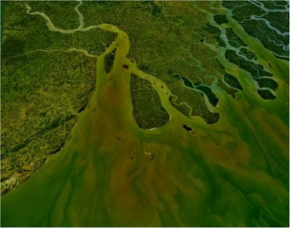In Peninsular region, they are found in deltas of the east coast and in the river valleys. These soils originate from the transported alluvium brought by the rivers. They can be divided into two types:
1. Young Khadar soils: these are newer alluvium of sandy, pale brown composition, found in lower areas of valley bottom which are flooded almost every year. It is non phorous, clayey and loamy.
2. Old Bhangar soils: these consist of older alluvium of clayey composition and are dark in colour.
They are coarse in nature, contain kankar (lime nodules), pebbles, gravels. They are found 30 m above flood level of the rivers.
nThey represent the ‘riverine alluvium’ brought down by Sutlej, Yamuna, Ghagra and other rivers of Indo-Gangetic Plains.
These soils are the most widespread soils covering an area of 8 lakh sq. km from Punjab to Assam. These are found in the river basin, flood plains and coastal areas. These soils are deep soils rich in potash but poor in nitrogen. These soils are covering 22.16 per cent of total area of India. The major rivers which are contributing in the formation of the alluvial soils are :Ganga river, Brahmaputra river, Sutlej river, Mahanadi river , Godavari river , Krishna river
Alluvial soils though differ greatly in texture, are very fertile on whole. They:
- Respond well to irrigation and manuring.
- Good for both rabi and kharif crops.
- Suitable for wheat, sugarcane, rice, cotton and oilseeds.
- In delta region, they are ideal for jute cultivation.
AREA/STATES
Alluvial soils of two types: deltaic coastal and inland alluviul.Found in Uttaranchal, U.P., Bihar, W. Bengal, Punjab, Haryana & Assam.In south,found in the plains and deltas in Andhra Pradesh, Orissa, Tamil Nadu.
Useful for agriculture since it is fertile.
Soil is rich in potash and lime but poor in nitrogen and humus.
Important crops – wheat, rice, sugarcane, cotton and jute.
It is very suitable for jute.
SUMMARY - ALLUVIAL SOIL
Alluvial soils are most extensive soil – most part
It is formed due to deposition of the rivers brought down from the upper course of the river. It is found on the combined plain land of the Indus and the Ganga-Brahmaputra rivers which includes Punjab, Haryana, U.P., Bihar and West Bengal.
The Deltaic alluvium is found in deltas of the Ganga-Brahmaputra, Godavari, Mahanadhi and Kaveri rivers.
The Coastal alluvium is found in coastal sides of Peninsular India.
Called ‘Riverine Soils’ – it is originally found in river basins .
Rice and wheat – 2 main crops being cultivated in the alluvial soil.
Deltaic alluvium is more fertile than the coastal alluvium because as the coastal alluvium being mixed with sands, has been lacked the meagre power of water-preserving than its counter parts. The deltaic alluvium has been riched with newly river-deposited alluvial components.
The economics of India, Pakistan and Bangladesh are dependent on alluvial soils.
The India, Bangladesh & Pakistan, i.e. combinedly the Indian sub-continent have been sectorising the agriculture into its primary occupation since a considerable period; and occasionally the accumulated river basin of Indus-Ganga-Brahmaputra, one of the riches source of fertile alluvial soil of the world, has occupied the region’s foremost areas. Thus, this type of agro friendly soil inhabitance consequently favours the economic upsurging among the totalwards.
Inland alluvium and Coastal Alluvium
Inland Alluvium soil is found in Indus river plains and the Ganga-Brahmaputra river plains whereas Coastal alluvium is found on the coastal regions of peninsular India
Inland Alluvium soil is found in Punjab, Haryana, U.P. Bihar, W. Bengal and Coastal Alluvium is found in Gujarath plains

Other Soils: The other soils in the category of the Indian soils are as follows:

DESERT SOIL

These soils cover 2 lakh sq. km areas in dry areas of Rajasthan, Gujarat, Punjab, and Haryana. These coarse soils are suitable for cultivation of jowar, bajara, cotton etc.
Saline and Alkaline Soils: These soils are found in the dry and marshy areas. These are locally known as Bhur, Rehu, Kallar. The accumulation of salts makes these soils infertile.

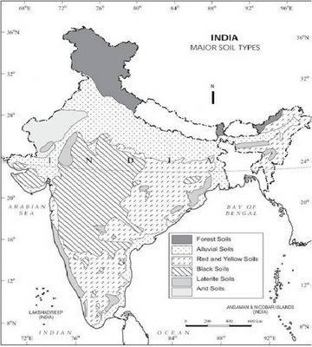
Mountain Soils:

Mountain soils are found in, as the name suggests, in mountainous regions. They are quite prone to soil erosion as a result of the top soil getting washed away due to the steep slopes of the mountains after a period of heavy rainfall.

These soils are mostly thin and infertile. These include peat, meadow and forest hill soils.
The major characteristics of this soil are:

*they are rich in humus

* are coarse and infertile. They are deficient in potash, phosphorous and lime.

*Tea, coffee, spices and tropical fruits
The states of Jammu and Kashmir, Himachal Pradesh and Uttaranchal, Assam, Sikkim as well as higher reaches of Arunachal Pradesh have mountain soil.

ARID AND DESERT SOILS

Large part of arid and semi-arid region of Rajasthan and adjoining areas of Punjab and Haryana
Desert soils are found in arid regions which receive very little rainfall.

*Low rainfall and high temperature are reasons for the formation of this soil .

*Having less than 50 cm rainfall . The high temperature adds to the loss of any remaining moisture in the soil. The soil is therefore sandy in nature. Thar Desert in Rajasthan has sandy soil.

*Covers an area of about 1.4 lakh sq km

* Originated from the mechanical disintegration of the ground rock of by deposition by wind

* Desert soil contain 90% of sand and 5% of clay. It contains rich percentage of soluble salts, but lack in organic matter.

* Are porus and coarse .

* They respond well to irrigation and manuring , especially phosphate and nitrate.- it can improve the soil fertility as it is seen in the case of Indira Gandhi Canal in Rajasthan.

* Only suitable for drought resistance crops like millets, barley, cotton, maize and pulses.

SALINE AND ALKALINE SOILS

Soils with high proportion of salts and alkalis are called saline and alkaline soils .
They are formed due to accumulation of tidal water in adjoining coasts where drainage is poor. They are found in drier parts of Bihar, Rajasthan, U.P., Punjab, Haryana, Maharashtra. These soils contain many salts like sodium, magnesium and calcium which make them infertile and render unfit for agriculture.

MARSHY SOIL

Found in continuously water-logged areas, or marshy areas especially in the coastal regions near the sea or near the deltas.
* It covers about 56,000 sq km.
* They are formed as a result of water-logging
* It contain iron and varying amount of decayed organic matter.
* Found in southern parts of Siwaliks, Jammu and Kashmir, U.P.

DENUDATION

Denudation is the process of wearing away of the earth’s surface. There are many agents of denudation.
1.Rivers
2.Glaciers
3.Winds
4.Sea waves, etc.

SOIL EROSION

Soil erosion is the main problem of our country . It is on the increase in recent years
Main reasons :

* Running water

* overgrazing

* faulty methods of agriculture

* Over irrigation

* Wind

* Men, plants and animals

Soil erosion happens when particles of soil come loose and are carried away by water or the wind. When it rains so much that the water cannot seep into the soil fast enough, the extra water flows down the slope, carrying soil particles with it. Many agricultural soils are easily eroded. The erosion problem is likely to be more severe on certain types of soils, on steep slopes, where there is intense rainfall, and where the vegetation is removed
Indirectly soil erosion helps in the soil forming because from wherever the soil is removed it is deposited elsewhere.

However it disturbs the agricultural pattern and should be prevented.
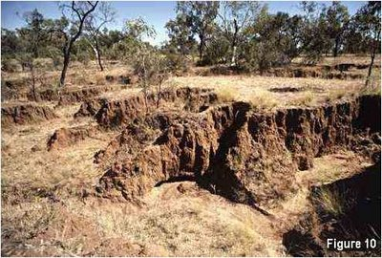
There are several ways in which soil erosion takes place due to running water.
a.Splash erosion
b.Sheet erosion
c.Gully erosion
d.Rill erosion

SPLASH EROSION

Splash erosion or rain drop impact represents the first stage in the erosion process. Splash erosion results from the bombardment of the soil surface by rain drops. Rain drops behave as little bombs when falling on exposed or bare soil, displacing soil particles and destroying soil structure. Studies have shown that splashed particles may rise as high as 0.6 metres above the ground and move up to 1.5 metres horizontally. Splash erosion results in the formation of surface crusts which reduce infiltration resulting in the start of runoff.

It is the first stage in the erosion process . It results from the bombardment of the soil surface by raindrops .It is the primary cause of soil detachment and soil disintegration.

It means that resettled sediment blocks soil pores resulting in surface crusting and lower infiltration.

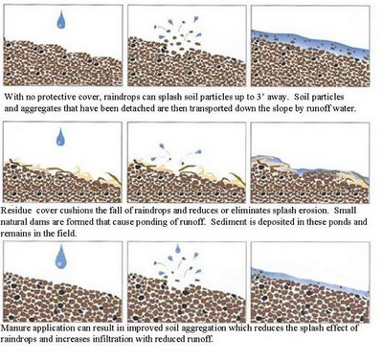
SHEET EROSION

Sheet erosion Occurs when thin layers of the topsoil are moved by the force of the runoff water, leaving the surface uniformly eroded

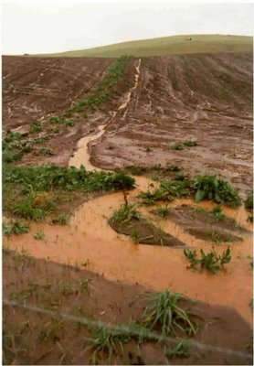
Cultivation on hill slopes is the main cause of soil erosion.
RILL EROSION
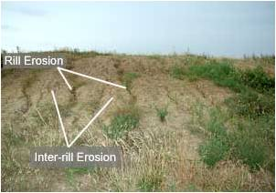
Rill erosion Caused by runoff water when it creates small, linear depressions in the soil surface. These are easily removed during land tillage
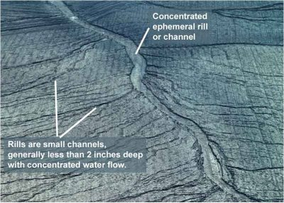
GULLY EROSION 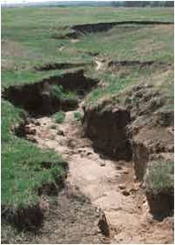
Unlike rill erosion, gullies are too deep to be removed during normal cultivation with ordinary farm implements. They are formed from small depressions, which concentrate water and enlarge until several join to form a channel. The deepening channel undermines the head wall, which retreats upslope. The gully then widens as the side-walls are worn back.
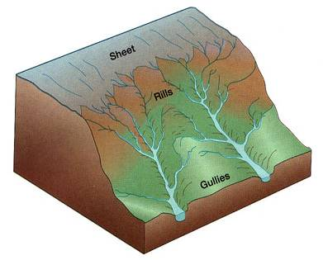
Sea or Shore erosion
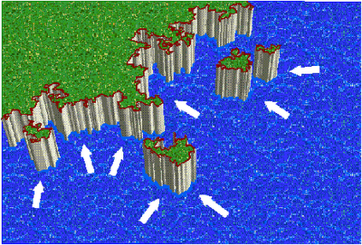
* Tidal waters of sea cause considerable damage to the soil along the sea coast.
* Powerful waves dash against sea-coast and break hanging cliff rocks.
* Broken material is then removed by the retreating sea waves.
* This type of erosion is seen throughout the eastern and western coasts of India.
Typical features of coastal erosion: from the initial cracks in less resistant rock through to arches, stacks, and stumps that can occur as erosion progresses.
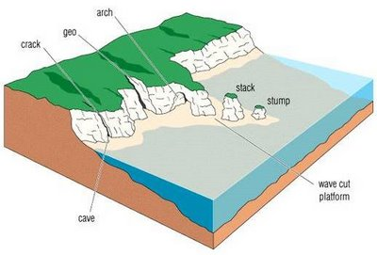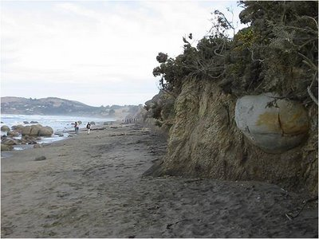
STREAM BANK EROSION:
Stream bank erosion is common along rivers, streams and drains where banks have been eroded, sloughed or undercut. However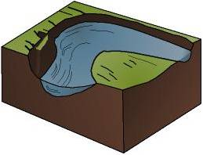, it is important to remember that a stream is a dynamic and constantly changing system.
It is natural for a stream to want to meander, so not all eroding banks which are slowly eroding are "bad" and in need of repair.
Generally, stream bank erosion becomes a problem where development has limited the meandering nature of streams, where streams have been channelized, or where stream bank structures (like bridges, culverts, etc.) are located in places where they can actually cause damage to downstream areas.
Stabilizing these areas can help protect watercourses f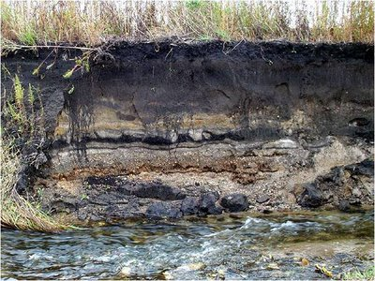rom continued sedimentation, damage to adjacent land uses, control unwanted meander, and improvement of habitat for fish and wildlife.
Streams and rivers change their courses by cutting one bank and depositing the silt on the others.
During flash floods, the damage is much acclerated.
Prevalent in the flood plains of Ganga, Yamuna, and other rivers.
As a result, large areas of agricultural land in the states of U.P., Rajasthan, M.P. have been transformed into ravines.
WIND:
Soil erosion by wind on extensive flat lands which are subject to windy dry season for part of the year.
The upper soil surface becomes loose and susceptible to wind erosion due to lack of moisture.

Overgrazing
Due to overgrazing, wind erosion occurs as the soil devoid of vegetation is directly exposed to the wind.

Faulty methods of agriculture
i)Shifting agriculture as in Northeast India
ii)Lack of crop rotation
iii)Wrong ploughing

LEACHING

In agriculture, leaching may refer to the loss of water-soluble plant nutrients from the soil, due to rainand irrigation. Soil structure, crop planning, type and application rates of fertilizers, and other factors are taken into account to avoid excessive nutrient loss. Leaching may also refer to the practice of applying a small amount of excess irrigation where th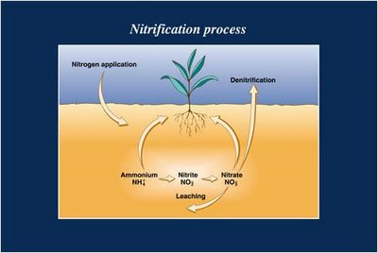e water has a high salt content to avoid salts from building up in the soil (salinity control). Where this is practiced,drainage must also usually be employed, to carry away the excess water.
Leaching is an environmental concern when it contributes to groundwatercontamination. As water from rain,flooding, or other sources seeps into the ground, it can dissolve chemicals and carry them into the underground water supply. Of particular concern are hazardous waste dumps andlandfills, and, in agriculture, excess fertilizer and improperly stored animal manure.
SHEET EROSION: Removal of thin layer of soil from a large area. In sheet erosion a thin layer of soil is removed from a large area.
RILL EROSION: A series of small channels on a slope carved by running water.
GULLY EROSION: Large, wide channels carved by running water. As a rule of thumb, a gully is large enough that it cannot be smoothed out with conventional tillage equipment.
SPLASH EROSION: Splash erosion where the soil is pulverised by the impact of heavy drops and hailstones as in case of convectional rainfall.
SOIL EROSION DUE TO HUMAN FACTOR:
* Loss of forest cover – annual rate- about 47,500 hectares
* Leads to sheet erosion on hilly slopes because water instead of sinking into the ground washes the soil down.
* In the second stage, in the absence of vegetation cover and washing off of the absorbent top soil, rills begin to appear on the landscape
* In the third stage, the water run off during heavy rains may develop deep grooves causing Gully erosion.
* The Outer Himalayas, the Western & Eastern Ghats are subjected to deforestation by man.
* These areas receive heavy rainfalls. Removal vegetation cover for different land use like railway lines, roads, buildings, or even agriculture has caused Sheet, Rill or Gully erosion
* Shifting cultivation – heavy rains wash away the bare soil from the slopes to the valleys below.
* Uncontrolled gazing of domestic animals in the valleys and the upper slopes.
WIND EROSION
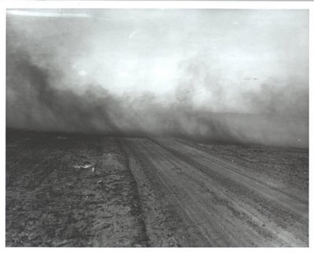
Wind erosion refers to the movement and deposition of soil particles by wind . It occurs when soil devoid of vegetation is exposed to high velocity wind.
Wind moves soil particles 0.1 – 0.5 mm in size in bouncing or hopping fashion and those greater than 0.5 by rolling. The former is known as saltation and the latter as soil creep. The particles less than 0.1mm or the fines particles detach into suspension.
Infact wind erosion is most visible in the suspension stage, as dust storms or subsequently as deposition along fence lines and across roads.
CAUSES OF SOIL EROSION IN INDIA
1)Heavy population pressure on land: - forest cover as low as 20.55% of total area – population continues to rise at a rapid rate – more forests are destroyed – heavy pressure on land.
2)Nature of Rainfall:- receives 80 to 90 per cent of rainfall in the monsoon season. – heavy downpour during during monsoon months causes floods. - remaining months – droughts – these affect soils
3)Overgrazing – number of domestic animals, esp cattle highest in world – cattle freely graze in open lands making them bare of vegetation-winds carry away dry soil particles - Rajasthan
4). Bad farming techniques – plough fields in traditional ways – small size of holdings, absence of terracing, contour cultivation, crop rotation, improper use of manure have caused erosion
5) Topography – North –Eastern parts of India, Shiwaliks and the hilly regions in south India are affected by soil erosion because of steep slopes and heavy rainfall. During heavy rainfall, soils are washed away by running water down the slope.
6) Deforestation: destruction of forests for cultivation – cutting of trees exposes the soil to water and wind which leads to soil erosion
REGIONS OF SOIL EROSION
*Rajasthan, Madhya Pradesh, Maharashtra, UP, Gujarat, Andhra Pradesh, Karnataka. Worst affected areas include:
* The badlands of Chambal and Yamuna rivers
* The piedmont zone of the western Himalayas
* The Chotanagpur plateau region
* The Tapi-Sabarmati valley region in Gujarat
* The regur soil area of Maharashtra
* The dry areas of Rajasthan, Gujarat and Haryana
EFFECTS OF SOIL EROSION:
* Loss of fertile top soil
* Lowering of the underground water table and decreasing soil moisture
* Drying of vegetation and extension of arid lands, increase in the frequency of droughts and floods
* Silting of river and canal beds, Recurrence of landslides, adverse effect on economic prosperity and cultural development
* Wind erosion reduces the productive capacity of soil, as most of the nutrients required by the plants are carried by the wind.
Prevention of soil erosion and soil conservation
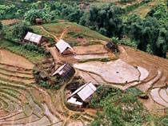
1.Terrace Farming:- On hilly slopes, terraces act as bunds and prevent the soil from being washed away.
2.Contour Ploughing: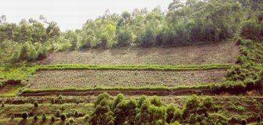
Ploughing along contourson a slope prevents soil being washed away by rainwater or by surface run off. Contours act like bunds. Terraces are levelled into step like small fields with even slope.
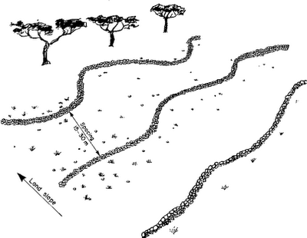
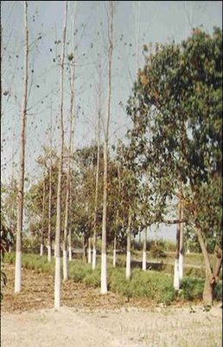
3)Afforestation: planting of trees along the edges of the fields, the waste land and on steepy slopes to prevent soil erosion as wellas to enahnce the capacity of the soil to retain water.
* increase area under forests and indiscriminate felling of trees must stop.

4) Shelter Belts: Farmers plant trees in several rows to check wind erosion. Known as wind breaks.
5) Strip cropping: Crops are grown in alternate strips of land to check the impact of the winds.
6) Construction of dams: Rivers cause soil erosion. Dams are buil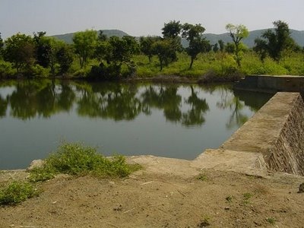t in the upper course of rivers to control erosion of soil. This would check the speed of water and thereby save soil from erosion
7) Ploughing Gullies:The gullies made in the soil are plugged with deposition of silt during heavy rains.
8) Shifting or Jhuming or slash and burn type of agriculture should be banned.
SOIL CONSERVATION SCHEMES
1.The centrally sponsored scheme of Integrated Watershed Management in the catchments of flood-prone rivers was launched during sixth Plan in eight flood-prone rivers of the Gangetic Basin covering seven States and one Union Territory. It aims at enhancing the ability of the catchment by absorbing larger quantity of rainwater, reducing erosion and consequent silt load in the stream and river beds and thus helping to mitigate the fury of floods in the productive plains.
2.A scheme for reclamation and development of ravine areas was launched in 1987-88 in MP, UP and Rajasthan. – included prepheral bunding to halt further ingress of ravines, afforestation of ravines, aforestaton of ravines for fuel, fodder and reclamation of shallow ravines.
3. Control of shifting cultivation is implemented since 1994-95 in the States of Arunachal Pradesh, Assam, Manipur, Meghalaya, Nagaland, Tripura
The integrated programme envisages settling of families practising shifting cultivation.
it helps them to practise terraced cultivation, raising of horticultural palantations and afforestation to support animal husbandry and to meet fuel and fodder requirements.
4) In urban areas, rain water harvesting is means of checking soil erosion, besides recharging ground water.
1.a. Name a rock from which black soils are formed? Write on characteristic of this soil?
Ans. Igneous rock. The soil has a great capacity to retain moisture.
b. Name the type of soil found on the summit of the Eastern Ghats. How is it formed?
Ans. Laterite soil. Laterite soil is formed by leaching.
c. i) Name any two regions where coastal alluvium is found.
ii.) Why is deltic alluvium more fertile than coastal alluvium?
Ans.c. i) The coastal alluvium occurs in the coastal strips of peninsular India and the plains of Gujarat.
ii. Deltic alluvium (Khaddar) is more fertile than coastal alluvium (Bhangar) as new layers are deposited year after year during monsoonal floods.
d. State any three factors which affect the soil formation.
Ans: i) WEATHERING: Extremes of temperature (as in the day and night temperatures in deserts), freezing and thawing of ice break down rocks, and favour soil formation.
ii) VEGETATION: The growth and decay of vegetation determines the humus content of the soil. Roots of plants penetrate the soil and make it porous.
iii. Bio-chemical processes taking place in the soil: Bacteria and fungi cause the decay of plants and animal remains. Some transform the atmospheric nitrogen into soil nitrogen.
2.a) Name one crop & one mineral associated with Black soil. Name two states in India where this type of soil is found.
Ans: Crop: Cotton, Mineral: Iron State : Maharashtra and Madhya Pradesh
b) How is Red soil formed? Mention two important properties of Red Soil.
Ans: Red soil is formed djue to weathering of ancient crystalline and metamorphic rocks of the Peninsular plateau. The properties of red soil are:
* it is loamy in deep depressions and in uplands, it consists of lose gravel- a highly coarse material.
* It is deficient in lime, nitrogen, phosphorus, and humus but fairly rich in potash.
C) Explain the following terms: i) Soil Erosion ii) Conservation of Soil
i) SOIL EROSION: It is the removal of topsoil by different agents of weathering such as running water, wind, over grazing and faulty methods of agriculture used by farmers.
ii) CONSERVATION OF SOIL: Conservation of soil is an effort made by humans to prevent soil erosion in order to retain fertility of soil.
d. With which type of soil is the term leaching associated? Name two regions in India where this type of soil is found.
Ans: Leaching is associated with laterite soil.
TWO REGIONS: 1. Assam Hills 2) Hill summit of Eastern and Western Ghats
Question: 3
a.Give a single word for the following:
i)The organic matter present in the soil formed by the decomposition of plants and animals - Humus
ii)The soil which are carried down by agents of gradation such as river, wind – Transported soil.
b.How does the soil of the Ganga Yamuna plain differ from that of central Maharashtra?
Soil found in Ganga-Yamuna plain is alluvial soil, whereas soil found near central Maharashtra is black soil. The soil of Ganga-Yamuna plain has been formed from the sediments deposited by rivers whereas soils of central Maharashtra have been formed due to the weathering of the lava.
c. Give reasons:
i.Alluvial soil can hold moisture and is very fertile: Since the soil is made up of fine particles, it can hold a lot of water.
ii.Black soil needs to be tilled after the first rain: When wet, the soil becomes sticky and is difficult to work with. So the soil needs to be tilted after the first rains.
iii.Red soil is ideal for dry farming: It is suited for dry farming as it does not require much moisture.
QUESTION 4
a.Read the feature of the soil carefully and identify the soil:
i)It develops insitu as a result of leaching - Laterite soil
ii)It develops on crystalline igneous rocks. - Red soil
iii)It develops insitu from volcanic rocks. - Black soil
iv)It is a transported soil and is formed by river sediments. – Alluvial soil
b.Mention any four human factors responsible for soil erosion. (2)
Deforestation, faulty methods of agriculture, urbanisation and industrialisation.
c.Name any two crops association with following soils: (3)
i. Alluvial soil - Rice and sugarcane
ii. Red soil - Rice and wheat
iii. Black soil - Cotton and wheat
d.‘Proper farming techniques can help in soil conservation.’ Explain by giving three examples.
* Terracing of hill slopes is effective in controlling soil erosion. Terracing is cutting into the hill slopes in a series of large steps made up of flat fields.
* Constructing bunds across hill slopes and filed boundaries is effective in reducing soil erosion. Bunds are low mud walls or embankments that help to obstruct the flow of water.
* Contour ploughing should be practised. It involves ploughing along the outline of the field in a circular manner. This prevents the soil from being washed away by running water.
A.Name four broad types of soils found in India.
Red, black, alluvial and laterite soil.
B.Give two reasons responsible for low fertility in laterite soil.
* It is formed due to leaching.
* It is poor in lime, phosphorous, nitrogen and potash which are fertile ingredients of a rich soil.
C.What is conservation of soil? Why is it necessary?
Soil conservation includes all those measures which help in protecting the soil from erosion and exhaustion
It is necessary because soil is our most important natural resource. It alone assures prosperous agriculture.
D.Mention any three characteristics of the northern plains.
* These are constituted by two large river basins i.e. the Indus river basin and the Ganga-Brahmaputra basin.
* These are very fertile plains.
* These plains support some of the highest population densities.
b. Differentiate between sheet erosion and gully erosion.
1. When top soil gets eroded from very large areas due to fast flowing rivers it is called sheet erosion.
Gully erosion occurs when running water etches out deep rivers creating a badland topography in an otherwise normal landscape.
2. The unprotected lands are most susceptible to sheet erosion. Sheet erosion is particularly harmful because it removes the top layer which is finer and fertile.
The main cause of gully erosion is the removal of vegetation, particularly of trees with their widespread binding roots. Gully erosion is also responsible for the formation of ravines.
d. Explain the formation of soil. Name three various forces of nature which contribute to the evolution of soil.
Soils are derived from parent rock material through the process of break up or wear and tear.
Various forces of nature i) changing temperature, ii) running water, iii) wind contribute to the evolution of soil.
QUESTION 7a. State two main differences between alluvial soil and red soil.
* Alluvial soil is a transporteed soil whereas red soil is residual.
* Alluvial soil is highly moisture retentive while red soil is not.
b. Why is laterite soil unsuitable for agriculture? Name an area in India where this soil is found.
-Laterite soil is unsuitable for agriculture due to its high content of acidity and inability to retain moisture. It is poor in nitrogen and lime.
c. How is Regur soil formed? Mention four important properties of Regur Soil.
These soils have been formed due to the solidification of lava spread over large areas during volcanic activity in the Deccan Plateau.
Features:
* it is well known for its capacity to hold moisture
* it is a deep fine grained soil
* it is dark in colour
* it is rich in lime, iron, magnesium and potash
* poor in phosphoric content.
* made of extremely fine material i.e., clayey material.
d. Mention two ways by which soil can get nitrogen.
Soil can get nitrogen by :
* By growing pulses as there are certain bacteria in the roots of pulses which have the ability to fix atmospheric nitrogen to form nitrogen compounds.
* By applying NPK fertilizer.
e. Explain the need for soil conservation in India. State two methods of soil conservation.
i) Soil is the most precious asset of India. More than 60% of the population is dependent on agriculture.
ii) Protective soil alone ensures progress of agriculture, forests and industrial development.
METHODS: i) Afforestation ii) Proper farming technique
7.a. How is red soil formed? Why are red soils not suitable for agriculture?
Red soil is formed due to weathering of ancient crystalline and metamorphic rocks.
Red soils are not suitable for agriculture because these are not retentive of moisture and are deficient in nitrogen, lime, phosphoric acid and humus. It is light in texture.
b. With reference to red soils in India,
i.Name two states where it found.
ii.State two disadvantages of this soil.
i. It is found in Tamil Nadu/Karnataka, Orissa, Andhra Pradesh, Goa.
ii.It is poor in humus, nitrogen, lime, phosphorus
not retentive of moisture.
8. a. Mention two important characteristic of laterite soil.
i. Laterite soils are acidic in nature, coarse and crumbly in texture.
ii. Due to lack of nitrogen, potassium and organic elements laterite soils lack fertility.
b.Name an area of black soil in India. Mention two crops grown in this soil.
Malwa region of India having a concentration of Black soil. Major crops are cotton and sugarcane.
c.How is alluvial soil formed? Why is this soil agriculturally important?
Alluvial soil is formed after the sedimentation of alluvium by rivers. This soil is agriculturally most important because it is fertile and renewed every year by rivers.
d.Name two important agents of erosion. For each, state one method of controlling the erosion caused.
Two important agents of erosion are : i) Running water
ii) Faulty agricultural activities.
Construction of dam and river embankment can control the soil erosion caused by running water. Scientific methods of cultivation like contour ploughing, terrace farming and conservation of moisture is the important conservative measure.
8. a. Mention two important characteristic of laterite soil.
i. Laterite soils are acidic in nature, coarse and crumbly in texture.
ii. Due to lack of nitrogen, potassium and organic elements laterite soils lack fertility.
b.Name an area of black soil in India. Mention two crops grown in this soil.
Malwa region of India having a concentration of Black soil. Major crops are cotton and sugarcane.
c.How is alluvial soil formed? Why is this soil agriculturally important?
Alluvial soil is formed after the sedimentation of alluvium by rivers. This soil is agriculturally most important because it is fertile and renewed every year by rivers.
d.Name two important agents of erosion. For each, state one method of controlling the erosion caused.
Two important agents of erosion are : i) Running water
ii) Faulty agricultural activities.
Construction of dam and river embankment can control the soil erosion caused by running water. Scientific methods of cultivation like contour ploughing, terrace farming and conservation of moisture is the important conservative measure.
9. How is red soil formed? State two reasons for the low productivity of red soil.
Red soil is formed by weathering of crystalline rocks.
Reasons for low productivity are:
i.Deficient in nitrogen and phosphoric acid
ii.Poor in humus and organic matter
iii.Coarse texture soil
iv.Non-retentive of water
MORE QUESTIONS:
1.Name one area where laterite soils is found on large scale.
Laterite soil is found in parts of Kerala, Goa, Tamil Nadu, Karnataka, Andhra Pradesh, on the summits of the Western and Eastern Ghats.
2. Name the type of soil found on the summits of the Eastern Ghats.
Laterite soil.
3. Why is laterite soil unsuitable for agriculture?
-unsuitable due to its high content of acidity and inability to retain moisture. It is poor in nitrogen and lime.
4. What is laterite soil?
Laterite soils are those formed under alternating wet and dry spells. They are composed of a mixture of hydrated oxides of aluminium and iron. They are poor in nitrogen, potash, lime. They are low in fertility but respond favourably to manuring and leaching of soil of its nutrients.
5. In which parts of India are laterite soils found?
They are found in Kerala, Karnataka, Maharashtra, A.P., Orissa and on the summits of Eastern and Western Ghats.
6. What is the meaning of leached soil?
It is the process by which soluble substances such as organic and mineral salts are washed out of the upper layer of soil into a lower layer by percolating rainwater
7. Name one Indian soil that has been formed by leaching.
Laterite soil.
8.Name the soil known for its self-ploughing quality and capacity to hold moisture. Name one cash crop for which it is most suited?
Black soil. The cash crop that grows best is Cotton/sugarcane.
9. How does the soil of the Ganga-Yamuna plain differ from that of central Maharashtra?
Soil found in Ganga-Yamuna plain is alluvial soil, whereas soil found near central Maharashtra is black soil. Alluvial soil is transported soil. Black soil is formed in situ.
10. State one feature of Mountain soil. Name two crops that can be grown on it.
* One feature of mountain soil is- it is rich in Iron but poor in lime.
* It is coarse in texture, friable in nature.
* Good for growing tea, coffee and fruits such as apples, plums, cherries.
11. Which soil is found suitable for growing coffee in Karnataka?
The soil found suitable for growing coffee is Mountain soil or Laterite soil, or Red soil.
12. Name the soil which is formed due to high temperatures and heavy rainfall with alternating wet and dry periods. Name two states where this type of soil is found.
aNS: Laterite soil. Found in Andhra Pradesh, Tamil Nadu, Assam and Kerala.
13. Write a short note on conservation of soil.
(Ans) Soil conservation is a set of management strategies for prevention of soilbeing eroded from the earth’s surface or becoming chemically altered by overuse, salinization, acidification, or other chemical soil contamination.
The following are the methods of soil conservation:
1) Afforestation: In some areas the original vegetation cover has been removed such as the Shiwalik Hills. In such areas afforestation and reforestation is needed to hold the soil.
2) Controlled grazing: The number of cattle grazing the slopes should be according to the carrying capacity of pastures.
3) Terraced agriculture: Slopes must be cut into a series of terraces for cultivation so as to slow down inflow of rainwater.
4) River dams: River dams should be built in the upper course of rivers to control floods and check soil erosion.
5) Contour ploughing: Contour ploughing terracing and bunding should be done to check soil wash on slopes. Ploughing is done at right angles to the hill slopes.
6) Crop methods: Crop rotation system should be adopted and the land should be allowed fallow for sometime.
7) Other methods: In areas of heavy rain, basin type of cultivation should be adopted. Tall trees should be grown as wind and shelter breaks belts in areas of strong winds.
What is soil?
Soil is a combination of four constituents: mineral material (sand, silt, clay and rocir and water. Soil is made from the breaking down of rocks and organic matter by physical, chemical and biological weathering processes.
What do you understand by ‘pedology’?
It is a branch of science which studies the soil.
Exploring Geography of Resources Resource Development
Ans. A number of factors contribute to the soil formation and fertility.
1.Parent rocks: - the rock on which the soil is formed decomposes and disintegrates under the processes of weathering. The characteristics of rocks influence the characteristics of soils. For example on lava rocks black soils and iron oxide rich rocks red soils are formed. 2.Climate: - climate influence the rate of weathering of rocks and type of vegetation, thus these influence the characteristics of soils. 3.Slope: - the nature of relief and slope influence the accumulation of soils. Mountains have thin soil cover but the plains have thick soil cover. 4.Time: - time provides maturity to the soil. 5.Various forces of nature such as change in temperature, actions of running water, wind and glaciers, activities of decomposers etc. contribute to the formation of soil. 6.Chemical and organic changes which take place in the soil are equally important.
Q.25 Mention the basis of classification of soils of India. Ans. On the basis of the factors responsible for soil formation, colour, thickness, texture, age, chemical and physical properties, the soils of India are classified in different types.
Q.26 Name the different types of soils found in India. Ans. the different soils found in India are:
1.Alluvial soils 2.Black soils 3.Laterite soils 4.Red and yellow soils 5.Forest and mountainous soils 6.Arid soils__.

1.What is the desired percentage of forest area essential for maintenance of the ecological balance in India? How are forests helpful?
Ans. Forest area in the country should be 33 per cent of geographical area for maintenance of the ecological balance. The livelihoods of millions of people depend on the forests.
1.What are waste lands & land put to non-agricultural uses?
Ans. Waste land includes rocky, arid and desert areas. Land put to other non-agricultural uses includes settlements, roads, railways, industry etc
1.What is main cause of land degradation in India?
Ans. Continuous use of land over a long period of time without taking appropriate measures to conserve and manage it has resulted in land degradation.

Q. Describe any four important characteristics of alluvial soils. Ans. Important characteristics of alluvial soil are:
1.The alluvial soil consists of various proportions of sand, silt and clay. 2.As we move inlands towards the river valleys, soil particles appear some what bigger in size. 3.In the upper reaches of the river valley i.e. near the place of the break of slope, the soils are coarse. Such soils are more common in piedmont (foot of mountains) plains such as Duars, Chos and Terai . 4.According to their age alluvial soils can be classified as old alluvial (Bangar) and new alluvial ( Khadar). The bangar soil has higher concentration of kanker nodules than the Khadar. Khadar soil has more fine particles and is more fertile than the bangar. 5.Alluvial soils as a whole are very fertile. 6.Mostly these soils contain adequate proportion of potash, phosphoric acid and lime which are ideal for the growth of sugarcane, paddy, wheat and other cereal and pulse crops. 7.Due to its high fertility, regions of alluvial soils are intensively cultivated and densely populated. 8.Soils in the drier areas are more alkaline and can be productive after proper treatment and irrigation.
Q. Describe the natural as well as human causes of land degradation in India.
Exploring Geography of Resources Resource Development
Ans. The natural causes are:
1.Erosion caused by running Water such as streams and rivers in hilly areas. 2.Depletion of forests. 3.Increase in salinity & alkalinity of land due to water logging and droughts. 4.Erosion caused by the wind in semi-arid and arid areas.
The human factors are:
1.Mineral processing activities: - The mineral processing like grinding of limestone for cement industry and calcite and soapstone for ceramic industry generate huge quantity of dust in the atmosphere. It retards the process of infiltration of water into the soil after it settles down on the land. 2.Industrial activities: - In recent years, industrial effluents as waste have become a major source of land and water pollution in many parts of the country. 3.Mining activities: - Mining sites are abandoned after excavation work is complete leaving deep scars and traces of over-burdening. 4.Deforestation: - In states like Jharkhand, Chhattisgarh, Madhya Pradesh and Orissa deforestation due to mining have caused severe land degradation. 5.Overgrazing: - In states like Gujarat, Rajasthan, Madhya Pradesh and Maharashtra overgrazing is one of the main reasons for land degradation. 6.Over irrigation: - In the states of Punjab, Haryana, western Uttar Pradesh, over irrigation is responsible for land degradation due to water logging leading to increase in salinity.
Q.22 Describe various measures to solve the problems of land degradation in India. Ans. There are many ways to solve the problems of land degradation.
1.Afforestation and proper management of grazing can help to some extent. 2.In dry and arid areas: - Planting of shelter belts of plants, control on over grazing, stabilisation of sand dunes by growing thorny bushes are some of the methods to check land degradation. 3.In industrial and suburban areas: - Proper management of waste lands, control of mining activities, proper discharge and disposal of industrial effluents and wastes after treatment can reduce land and water degradation.
Q.23 Define the concept of soil. Ans. The top most layer of the earth crust which is composed of organic and non-organic matter is called soil. Soil is the most important renewable natural resource. It is the medium of plant growth and supports different types of living organisms on the earth. The soil is a living system. It takes millions of years to form soil up to a few cm in depth.
Q.24 Describe the factors which control the formation of soil.
Exploring Geography of Resources Resource Development
Ans. A number of factors contribute to the soil formation and fertility.
1.Parent rocks: - the rock on which the soil is formed decomposes and disintegrates under the processes of weathering. The characteristics of rocks influence the characteristics of soils. For example on lava rocks black soils and iron oxide rich rocks red soils are formed.
2.Climate: - climate influence the rate of weathering of rocks and type of vegetation, thus these influence the characteristics of soils.
3.Slope: - the nature of relief and slope influence the accumulation of soils. Mountains have thin soil cover but the plains have thick soil cover.
4.Time: - time provides maturity to the soil.
5.Various forces of nature such as change in temperature, actions of running water, wind and glaciers, activities of decomposers etc. contribute to the formation of soil.
6.Chemical and organic changes which take place in the soil are equally important.
Q.25 Mention the basis of classification of soils of India.
Ans. On the basis of the factors responsible for soil formation, colour, thickness, texture, age, chemical and physical properties, the soils of India are classified in different types.
Q.26 Name the different types of soils found in India.
Ans. the different soils found in India are:
1.Alluvial soils 2.Black soils 3.Laterite soils 4.Red and yellow soils 5.Forest and mountainous soils 6.Arid soils__.
Q. Describe any four important characteristics of alluvial soils.
Ans. Important characteristics of alluvial soil are:
1.The alluvial soil consists of various proportions of sand, silt and clay.
2.As we move inlands towards the river valleys, soil particles appear some what bigger in size.
3.In the upper reaches of the river valley i.e. near the place of the break of slope, the soils are coarse. Such soils are more common in piedmont (foot of mountains) plains such as Duars, Chos and Terai .
4.According to their age alluvial soils can be classified as old alluvial (Bangar) and new alluvial ( Khadar). The bangar soil has higher concentration of kanker nodules than the Khadar. Khadar soil has more fine particles and is more fertile than the bangar.
5.Alluvial soils as a whole are very fertile.
6.Mostly these soils contain adequate proportion of potash, phosphoric acid and lime which are ideal for the growth of sugarcane, paddy, wheat and other cereal and pulse crops.
7.Due to its high fertility, regions of alluvial soils are intensively cultivated and densely populated.
8.Soils in the drier areas are more alkaline and can be productive after proper treatment and irrigation.
Exploring Geography of Resources Resource Development
Q.28 Mention important regions of alluvial soils. Ans. important regions of alluvial soils are: a. The entire northern plains are made of alluvial soil. These have been deposited by three important Himalayan river systems– the Indus, the Ganga and the Brahmaputra. b. These soils also extend in Rajasthan and Gujarat through a narrow corridor. c. Alluvial soil is also found in the eastern coastal plains particularly in the deltas of the Mahanadi, the Godavari, the Krishna and the Kaveri rivers.
Q.29 Describe any four characteristics of black soil found in India. Ans. Important characteristics of black soils are: a. These soils are black in colour and are also known as regur soils. Black soil is ideal for growing cotton and is also known as black cotton soil. b. It is believed that climatic conditions along with the parent rock material are the important factors for the formation of black soil. c. The black soils are made up of extremely fine i.e. clayey material. d. They are well-known for their capacity to hold moisture. e. In addition, they are rich in soil nutrients, such as calcium carbonate, magnesium, potash and lime. These soils are generally poor in phosphoric contents. f. They develop deep cracks during hot weather, which helps in the proper aeration of the soil. g. These soils are sticky when wet and difficult to work on unless tilled immediately after the first shower or during the pre-monsoon period.
Q.30 Mention important regions of black soils. Ans. important regions of black soils are: a. This type of soil is typical of the Deccan trap (Basalt) region spread over northwest Deccan plateau and is made up of lava flows. b. They cover the plateaus of Maharashtra, Saurashtra, Malwa, Madhya Pradesh and Chhattisgarh and c. Extend in the south east direction along the Godavari and the Krishna valleys.
Q.31 Describe any four characteristics of red and yellow soil found in India. Ans. Important characteristics of red and yellow soils are: a. Red soil develops on crystalline igneous rocks in areas of low rainfall. b. These soils develop a reddish colour due to diffusion of iron in crystalline and metamorphic rocks. c. It looks yellow when it occurs in a hydrated form.
Q.32 Mention important regions of red and yellow soils. Ans. important regions of red and yellow soils are: a. In the eastern and southern parts of the Deccan plateau. b. Yellow and red soils are also found in parts of Orissa, Chhattisgarh, southern parts of the middle Ganga plain and c. Along the piedmont zone of the Western Ghats.
Q.33 Describe any four characteristics of Laterite soil found in India. Ans. Important characteristics of Laterite soils are:
Exploring Geography of Resources Resource Development
a. Laterite has been derived from the Latin word ‘later’ which means brick. b. The laterite soil develops in areas with high temperature and heavy rainfall. c. This is the result of intense leaching due to heavy rain. d. Humus content of the soil is low because most of the micro organisms, particularly the decomposers, like bacteria, get destroyed due to high temperature. e. Laterite soils are suitable for cultivation with adequate doses of manures and fertilizers. f. After adopting appropriate soil conservation techniques particularly in the hilly areas of Karnataka, Kerala and Tamil Nadu, this soil is very useful for growing tea and coffee. g. Red laterite soils in Tamil Nadu, Andhra Pradesh and Kerala are more suitable for crops like cashew nut.
Q.34 Mention important regions of laterite soils. Ans. important regions of laterite soils are: a. These soils are mainly found in Karnataka, Kerala, Tamil Nadu, Madhya Pradesh, and the hilly areas of Orissa and Assam
Q.35 Describe any four characteristics of arid soil found in India. Ans. Important characteristics of arid soils are: a. Arid soils range from red to brown in colour. b. They are generally sandy in texture and saline in nature. c. In some areas the salt content is very high and common salt is obtained by evaporating the water. d. Due to the dry climate, high temperature, evaporation is faster and the soil lacks humus and moisture. e. The lower horizons of the soil are occupied by Kankar because of the increasing calcium content downwards. The Kankar layer formations in the bottom horizons restrict the infiltration of water. f. After proper irrigation these soils become cultivable as has been in the case of western Rajasthan.
Q.36 Describe any four characteristics of forest soil found in India. Ans. Important characteristics of forest soils are: a. These soils are found in the hilly and mountainous areas where sufficient rain forests are available. b. The soils texture varies according to the mountain environment where they are formed. c. They are loamy and silty in valley sides and coarse grained in the upper slopes. d. In the snow covered areas of Himalayas, these soils experience denudation and are acidic with low humus content. e. The soils found in the lower parts of the valleys particularly on the river terraces and alluvial fans are fertile.
Q.37 Define the term soil erosion. Ans. The denudation of the soil cover and subsequent washing down is described as soil erosion. The soil erosion is of many types: a. When the running water cuts through the clayey soils and makes deep channels it is called gullies. b. The land becomes unfit for cultivation and is known as bad land. c. In the Chambal basin such lands are called ravines. d. Sometimes water flows as a sheet over large areas down a slope. In such cases the top soil is washed away. This is known as sheet erosion.
Exploring Geography of Resources Resource Development
e. Wind blows loose soil off flat or sloping land known as wind erosion.
Q.38 State how is the balance between the soil formation and soil erosion get disturbed? Explain the factors which cause soil erosion.
Ans. This balance is disturbed due to human activities like a. deforestation, b. over-grazing, c. construction and mining, d. Defective methods of farming: Ploughing in a wrong way i.e. up and down the slope form channels for the quick flow of water leads to soil erosion. It is also disturbed due to natural forces like: a. Wind, b. Glacier and c. Running water leads to soil erosion.
Q.39 Explain the different methods of controlling soil erosion. Ans. Some of the methods of controlling soil erosion are: a. In Hilly areas: Ploughing along the contour lines can slow down the speed/flow of water down the slopes. This is called contour ploughing. Steps can be cut out on the slopes making terraces. Terrace cultivation restricts erosion. Western and central Himalayas have well developed terrace farming. b. Agricultural regions: Large fields can be divided into strips. Strips of grass are left to grow between the crops. This breaks up the force of the wind. This method is known as strip cropping. c. Dry areas: Planting lines of trees to create shelter also works in a similar way. Rows of such trees are called shelter belts. These shelter belts have contributed significantly to the stabilisation of sand dunes and in stabilising the desert in western India.

